Name: _______________________ Class: __________ Date: _______
Instructions: Write answers in the right-hand column. Score: ___________ / 69 marks
Section A— Multiple choice (10 marks)

 | The law makes you wear a bike helmet whenever you ride your bike. The reason for this law is:  A science has proven that helmets reduce the risk of head injuries if you fall off your bike.  B helmets help you to maintain a constant body temperature.  C helmets prevent your hair getting in your eyes, which would be dangerous.  D helmets help police to identify cyclists who ride through red lights. | a
 | Brent is studying how volcanoes form. Which branch of science is he working in?  A Physics  B Chemistry  C Geology  D Biology | c
 | The diagram below shows liquid in a measuring cylinder.  Which of the following measurements of its volume is most accurate?  A 34 mL  B 35 mL  C 36 mL  D There is not enough information to decide.  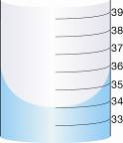 | a
 | Eddie notices that his Bunsen burner is making a hissing noise. The most sensible action he should take immediately is to:  A tell his teacher.  B run for the door.  C blow out the flame.  D turn off the gas at the gas tap. | D
 | When heating a test-tube, you should point it away from everyone, including yourself. Which is the best reason for this rule?  A It’s easier to see what’s going on in the test-tube.  B Hot liquid can spit out and hit people.  C To stop people seeing what you are doing.  D This way, the liquid is less likely to spit out. | b
 | Which of the following is a quantitative observation?  A The water was hot.  B The water was clear.  C The water was at a temperature of 34ºC.  D The water was colourless. | c
 | Which is the correct way of writing the unit symbol for kilogram?  A kg  B kgs  C KG  D Kg | a
 | Evan ran a series of experiments testing how high different balls bounced. Which of the following is not a good conclusion for his experiments?  A Balls bounced higher on concrete than on grass.  B Tennis balls bounced higher than squash balls.  C Balls bounce higher when dropped from greater heights.  D The experiment was lots of fun and I learnt a lot about balls. | d
 | Which of the following observations is continuous?  A The brands of tomato sauce in a supermarket.  B The colours of cars in a car park.  C The height of gum trees in a forest.  D The types of animals kept in a zoo. | c
 | A prac team heated water as part of an experiment. Each wrote up this part of the procedure in different ways. Which of the following is the best description of what happened in the experiments.  A We heated some water.  B We heated 100 mL of water.  C We placed 100 mL of water in a 250 mL beaker and heated it until it reached 60ºC.  D We heated 100 mL of water in a 250 mL beaker. | c

Section B— Short answer (50 marks)

- ` | Classify the following as an example of astronomy, biology, chemistry, ecology, geology, physics or psychology.  a Dave is looking through his telescope at the stars.  b Nasir is investigating what food wombats eat.  c Steve is studying why children want to play with toys while old people do not.  d Patrice is testing what substances are burnt by acids.  e Manni is investigating how to make electrical devices use less energy.  f Vicki is working out what pollution is doing to the local creek.  g Jen is studying different rock types. | a astronomy  b biology  c psychology  d chemistry  e physics  f ecology  g geology | 6
 | List four observations that could be made to describe lemon mineral water. | Observations that could be made: liquid, colour (pale yellow), clear, bubbles of gas rise when the top is released, sweet. | 4
 | Below is a jumbled list of instructions for lighting a Bunsen burner. Modify this list and use the letters given (A, B, C, D etc.) to place the instructions in the correct order:  A Turn on the gas.  B Light a match.  C Connect Bunsen burner to the gas.  D Turn the collar to close the airhole.  E To obtain a blue flame, open the airhole.  F Place the Bunsen burner on bench mat.  G Hold the match about 1 cm from the top of the barrel.  H The Bunsen should light and the flame should be yellow. | F  C  D  B  G  A  E  H  An alternative and equally valid list could be:  D  F  C  B  G  A  E  H | 8
 | Name the parts of the Bunsen burner labelled in the diagram below.  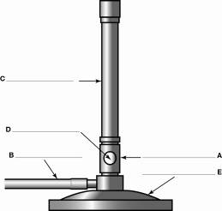 | A = collar  B = gas hose  C = barrel  D = airhole  E = base | 5
 | Explain how the yellow flame from a Bunsen burner can be considered to be the safety flame, when it is hot enough to burn. | All flames are hot but yellow flames are far less hot than blue flames.  The yellow flame is called a safety flame because it is ‘cooler’ than the blue flame and is more visible. | 2
 | Classify the following observations as qualitative or quantitative:  a The setting Sun was bright red.  b The Sun set at 8.24 pm.  c It took six seconds to set.  d The day had been very hot.  e The Sun is 150 million kilometres from Earth. | a Qualitative  b Quantitative  c Quantitative  d Qualitative  e Quantitative | 5
 | State the correct symbol for the following units:  a kilogram  b seconds  c millilitre  d degrees Celsius  e centimetre | a kg  b s  c mL  d ºC  e cm | 5
 | Name each of the following pieces of equipment:  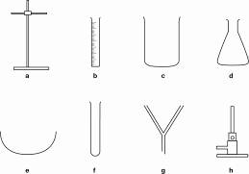 | a Retort stand  b Measuring cylinder  c Beaker  d Conical flask  e Watch-glass  f Test-tube  g Filter funnel  h Bunsen burner | 8
 | Construct an appropriate conclusion for an experiment in which the aim was:  To find out whether cream pours slower than water out of the same sized jug. | Various answers possible. The most likely is something similar to:  Cream pours slower than water out of the same sized jug. | 2
 | The following statements were written as part of a prac report. Identify which statement is the:  a Purpose  b Hypothesis  c Materials  d Method  e Conclusion.  Statement 1  100 mL of water was put in a large beaker. 100 mL of cooking oil was slowly dripped onto its surface.  Statement 2  I think that cooking oil will float on top of water.  Statement 3  cooking oil, water, large beaker  Statement 4  The oil formed a layer on top of the water.  Statement 5  To test if oil floats on water. | a Purpose = Statement 5  b Hypothesis = Statement 2  c Materials = Statement 3  d Method = Statement 1  e Conclusion = Statement 4 | 5

Section C— Thinking scientifically (9 marks)

 | The length of the ant in the diagram below is most likely to be:  A 2 mm  B 6.5 mm  C 8.5 mm  D 11 mm  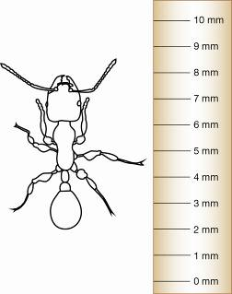 | b
 | The ant in the diagram is 4.0 mm. The beetle is drawn to the same scale as the ant. The length of the beetle is most likely to be:  A 4.0 mm  B 6.0 mm  C 8.0 mm  D 10 mm  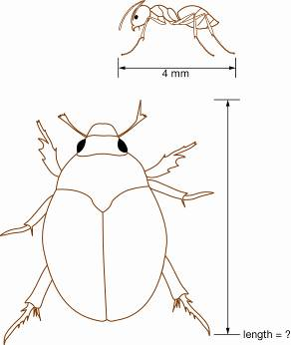 | c
 | The temperature measured by the thermometer shown is:  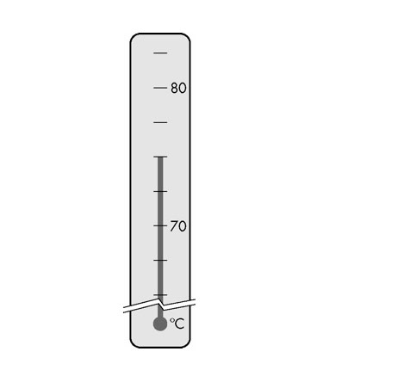  A 70.3°C  B 73°C  C 75°C  D 70.6°C | c
 | Maddie measured how far an elastic band stretched when masses were hung from it. Throughout the experiment she made sure she always used the same make and thickness of elastic band.  From this information, which of the following is the variable that she is changing (the independent variable)?  A How far an elastic band stretches.  B The make of elastic band.  C The masses hung from the elastic band.  D The thickness of the elastic band. | C
 | Controlled variables are factors that are kept the same throughout the experiment. From the experiment in Q4, Maddie’s controlled variables were:  A The stretch of the elastic band and the masses hung from it.  B The stretch of the elastic band and its make.  C The make of elastic band and its thickness.  D The masses hung from the elastic band and its make. | c
 | Which of the pie charts best represents the measurements in the table below?  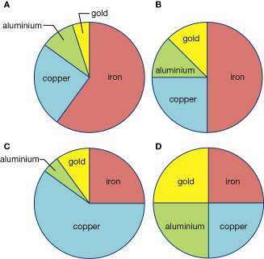  A pie chart A  B pie chart B  C pie chart C  D pie chart D | a
  Metal | iron | copper | aluminium | gold | TOTAL
  Percentage | 60% | 25% | 10% | 5% | 100%
 | Which of these graphs best represents the measurements in the table below?  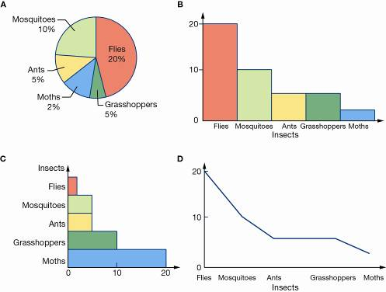  A graph A  B graph B  C graph C  D graph D | B
  Insects | Flies | Mosquitoes | Ants | Grasshoppers | Moths
  Number | 20 | 10 | 5 | 5 | 2
 | The big bad wolf blew down the houses of the three little pigs. A nearby scientist counted how many times the big bad wolf needed to blow to collapse each house. The results are shown in the bar graph below. How many blows were required to knock down each house?  A Brick 40, twigs 5, straw 10  B Brick 40, twigs 10, straw 5  C Brick 5, twigs 10, straw 40  D Brick 40%, twigs 10%, straw 5%  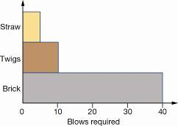 | b
 | Based on the results in Q8, how much stronger are brick houses than twig houses?  A Four times stronger  B Two times stronger  C Ten times stronger  D Not enough information to decide | a
 | Based on the results in Q8, how much stronger are brick houses compared with straw houses?  A Four times stronger  B Two times stronger  C Eight times stronger  D Not enough information to decide | c

